1 – Note taking
You will need to take notes from one of the following sources. Corbett Maths videos are freely available. If you have a Hegarty Maths login from Y11, then you may prefer to use that.
Corbett Maths video: https://youtu.be/_2NvkxBchm8
Hegarty Maths video: 166 - Expand triple brackets

2 – Worked Examples
Read through the Worked Examples, then use the same method and layout to attempt the ‘Your turn’.
Worked Example 1:
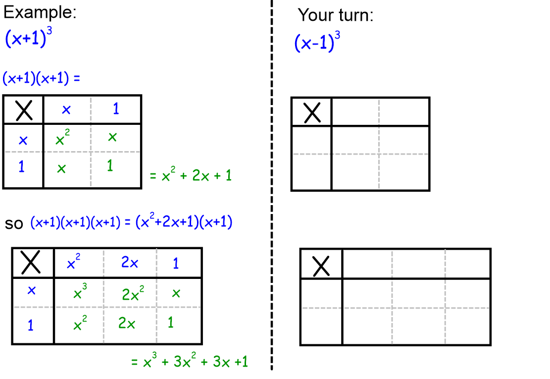

Worked Example 2:
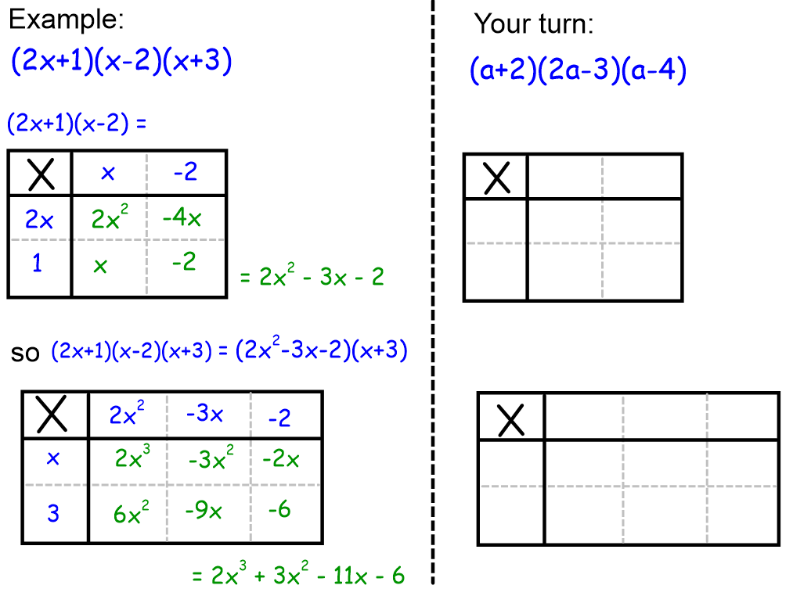

3 – Practice
Complete the three tasks, and use the answers to mark your work after.
Task 1:

Task 2:

Task 3:

Answers 1:
Answers 2:

Answers 3:

- Assessment
- Expand and simplify:

- Expand and simplify:

