1 – Note taking
You will need to take notes from one of the following sources. Corbett Maths videos are freely available. If you have a Hegarty Maths login from Y11, then you may prefer to use that.
Corbett Maths video: https://youtu.be/phlus4x0UqM
Hegarty Maths video: 193 – Simultaneous equations by elimination 4

2 – Worked Examples
Read through the Worked Examples, then use the same method and layout to attempt the ‘Your turn’.
Worked Example 1:
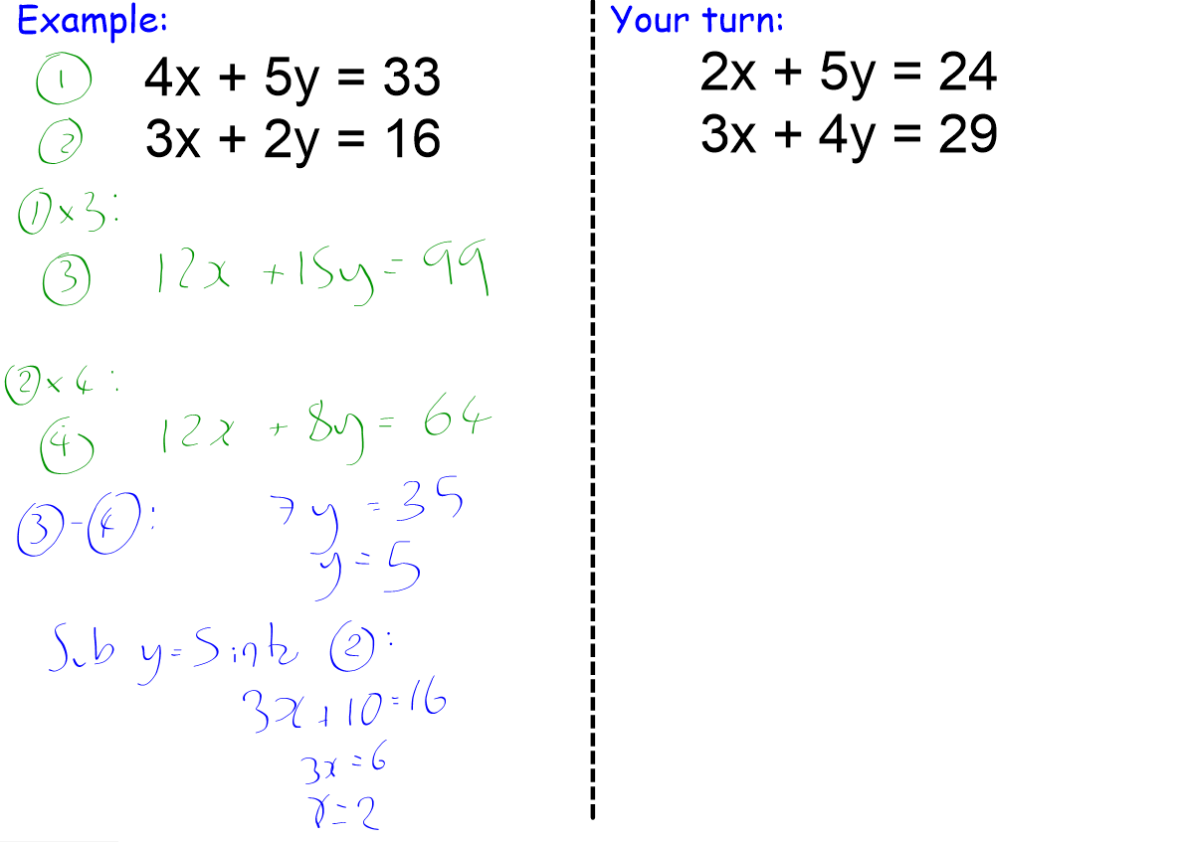
Worked Example 2:
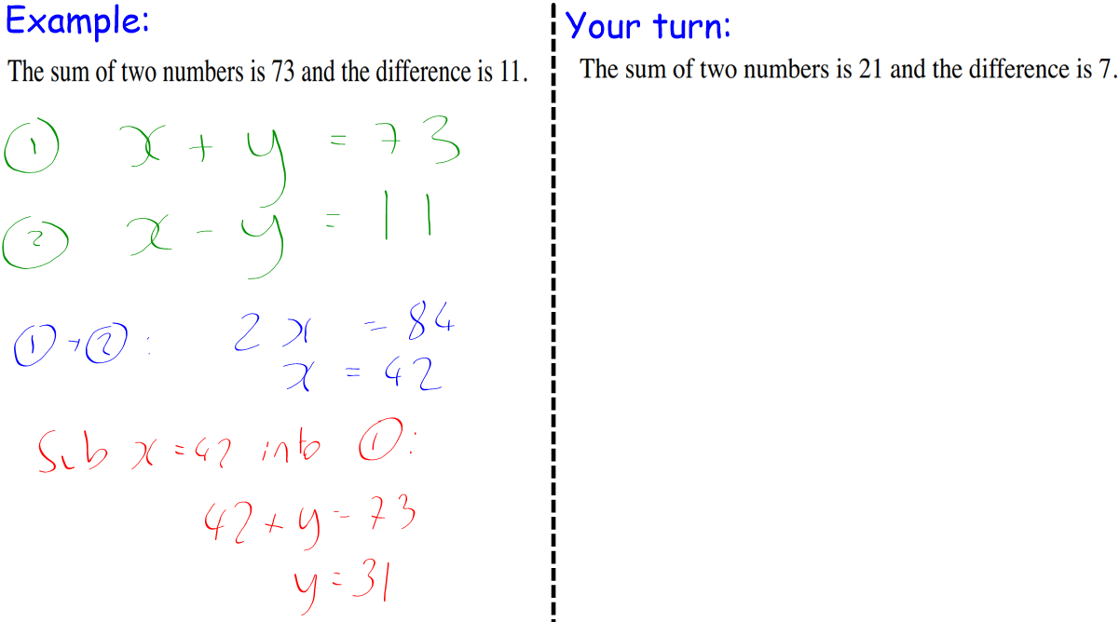

Worked Example 3:
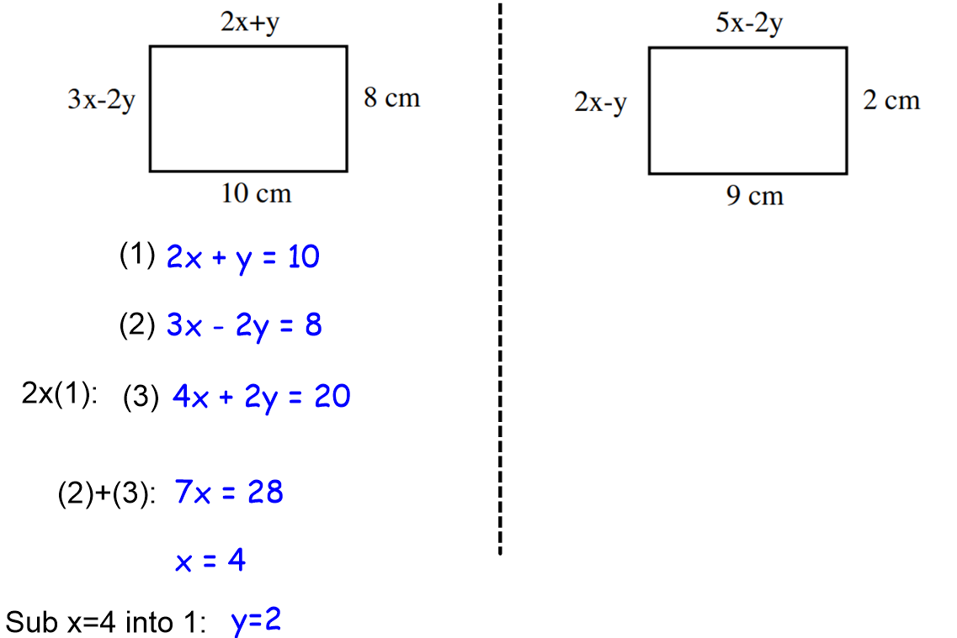

3 – Practice
Complete the three tasks, and use the answers to mark your work after.
Task 1:
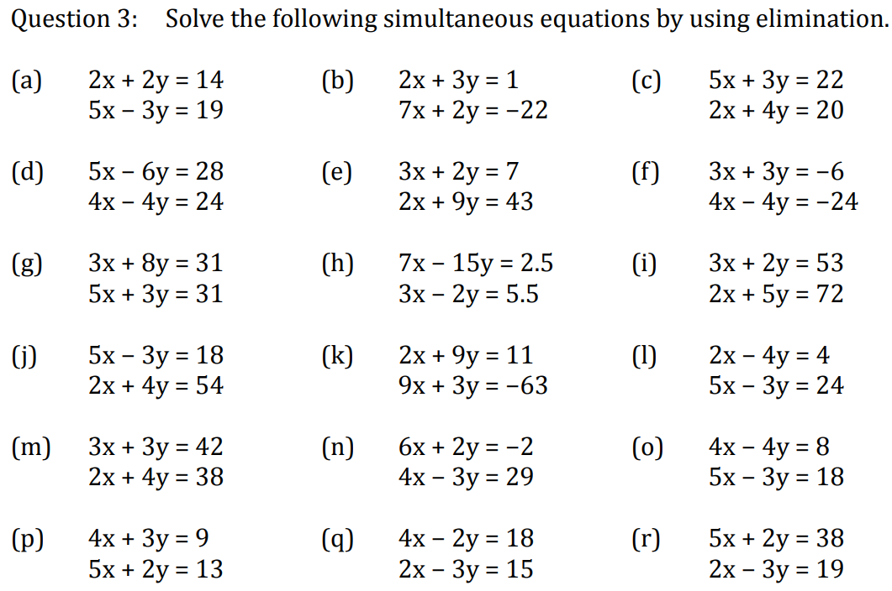

Task 2:

Task 3:
c) d)

Answers 1:

Answers 2:

Answers 3:

4 - Assessment

- Solve the simultaneous equations:

- Solve the simultaneous equations:

3)

The perimeter of the triangle is 32cm. Find the values of a and b.

